For this pretest, you will create a new *contrived* project.

Create a new C# windows form app (call the solution PretestCh10-11 and call the project Presidents) to create a **very simplistic** 2 form US Presidents matching game.

Please see the next 2 pages for the way each form should look before the program is run.

Please see Pages 4 – 5 for actual program runs.

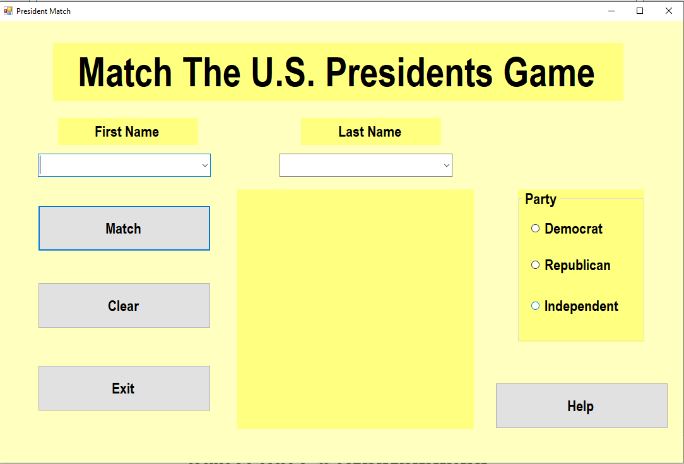

For this main screen, the first name and last name are in ComboBox (dropDownLists). These should be populated programmatically from the arrays you have been given.

* If the first name and last name match, you should show the associated image.
* If they do not match, you should show the No Image Available image.
* In addition, if you find a match, also make sure that the right radio button is checked.

When the Help button is clicked, the (Help) screen appears.

All buttons, radioButtons, dropDownLists, etc. should be operational. Tab Order, Cancel Button, Accept Button, and Start Position set also.

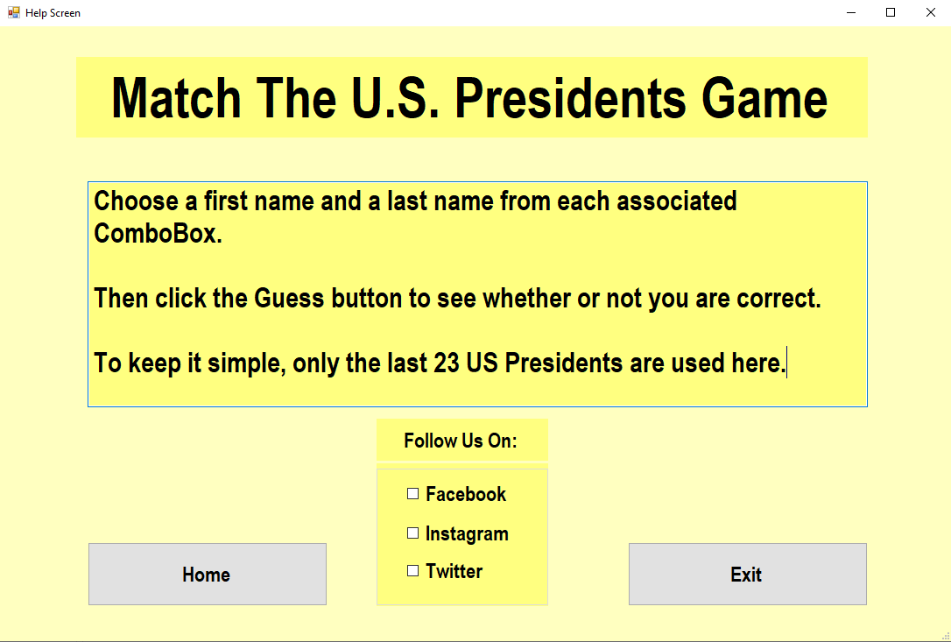

For this help screen, all buttons and checkboxes should be operational.

When the Home button is clicked, the first (Home) screen should appear.

If the Exit button is clicked and the user chooses Yes to exit the program, the program should first print out any/all Follow Us On checkboxes that are checked.

Again, all buttons should be operational. The Tab Order, CancelButton, AcceptButton, and StartPosition should be set, as on the Home page.

Try to modularize as much as possible. Have your buttons, etc. act like *drivers*. Use good function, variable, and constant names.

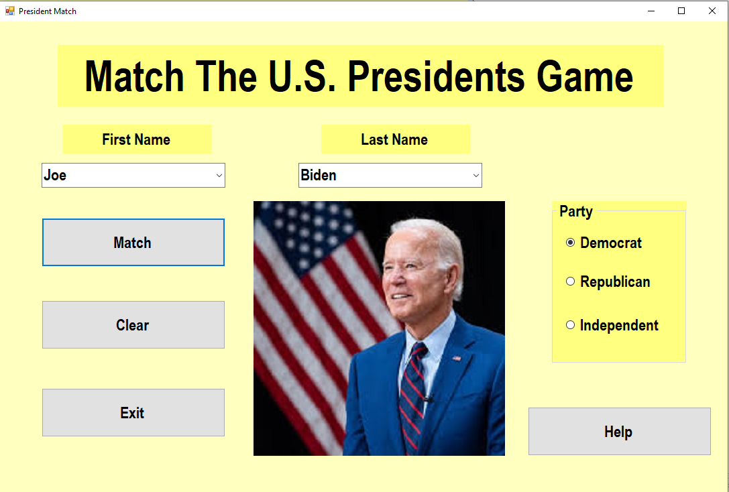

Note that there is not much to this *game*, as the President’s first and last names are already in the correct order. That’s OK.

Please try to set your form to look as much like this one as possible. Remember to create an image folder and change the image paths I have set (for my machine) to your machine.

